B22DCT059 - Trần Anh Dũng

Ques1:
a.
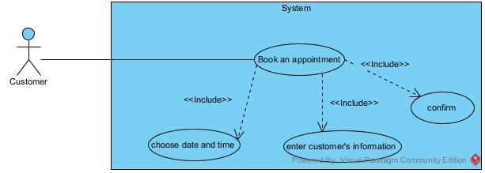
b.
Ques2:
a.Entity Extract
- User: username, password, role, fullName
- ManagementStaff
- SaleStaff
- TechinicalStaff
- WarehouseStaff
- Customer: phone, address
- Supplier: name, phone, address
- Part: name, type, price
- PartStat: revenue
- ImportPart: amount, price
- RequestPart: amount, price
- ImportInvoice: date, totalPrice
- ServiceStat: revenue
- Service: name, price, description
- AppointmentService: price
- Appointment: date, finishTime
- Car: name, description
- Invoice: date, totalPrice
b.
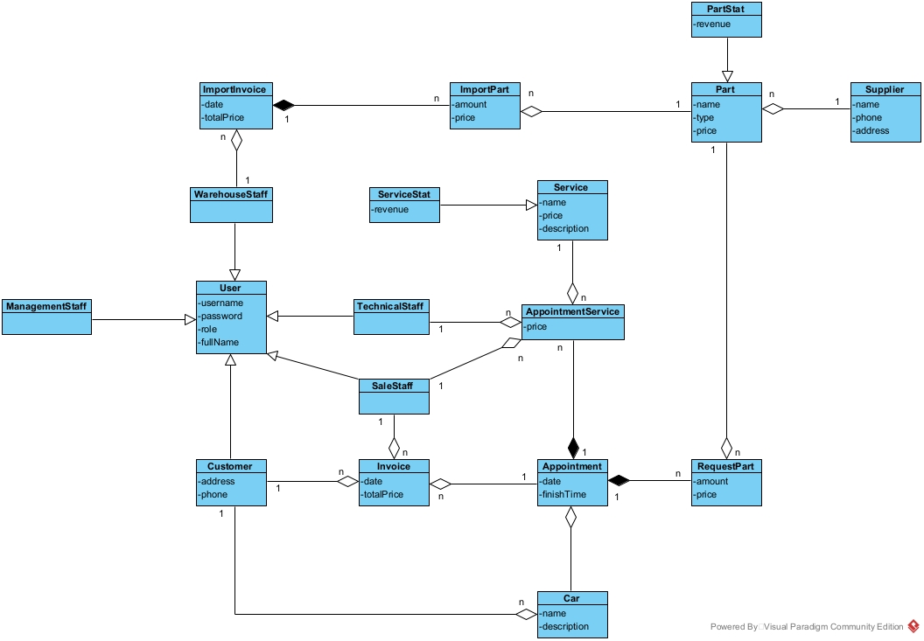
Ques3:
a.
b.
Ques4:
a.
b.

